Difference between git and gitHub

Programming language wordings are very intuitive these days. By hearing the name of a particular language, we start imagining what all it will be.

[Java](https://www.javatpoint.com/java-tutorial) and [Javascript](https://www.javatpoint.com/javascript-tutorial) are very similar to the names ham and hamster, the logo of [python](https://www.javatpoint.com/python-tutorial) is intertwined with the image of snakes.

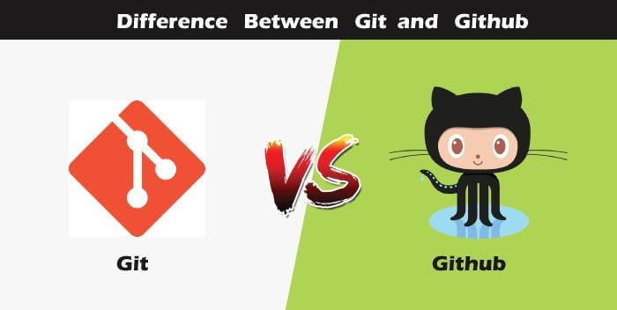

So, someone looking at git and github would find any apparent connection between them. Let us see git and github in detail with the differences between them.

Git

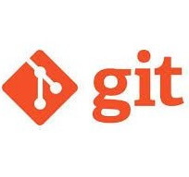

There are many words to define [git](https://www.javatpoint.com/git), but it is an open-source distributed version control system in simpler words.

Let us break each component in the definition and understand it.

* **Open-source -** A type of computer software released under a specific license. The users are given permissions to use the code, modify the code, give suggestions, clone the code to add new functionality. In other words, if the software is open-source, it is developed collaboratively in a public manner. The open-source softwares is cheaper, more flexible, and lasts longer than an authority or a company. The products in the source code include code, documents, formats for the users to understand and contribute to it. Using open-source a project can be expanded to update or revise the current features. Unix and Linux are examples of open-source softwares.
* **Control system -** The work of a control system is to track the content. In other words, git is used to storing the content to provide the services and features to the user.
* **Version Control system -** Just like an app has different updates due to bugs and additional feature addition, version changes, git also supports this feature. Many developers can add their code in parallel. So the version control system easily manages all the updates that are done previously.  
  Git provides the feature of branching in which the updated code can be done, and then it can be merged with the main branch to make it available to the users. It not only makes everything organized but keeps synchronization among the developers to avoid any mishap. Other examples of version control systems are Helix core, Microsoft TFS, etc.
* **Distributed version control system -** Here distributed version control system means if a developer contributes to open source, the code will also be available in his remote repository. The developer changes his local repository and then creates a pull request to merge his changes in the central repository. Hence, the word distributed means the code is stored in the central server and stored in every developer's remote system.

**Why is git needed?**

When a team works on real-life projects, git helps ensure no code conflicts between the developers. Furthermore, the project requirements change often. So a git manages all the versions. If needed, we can also go back to the original code. The concept of branching allows several projects to run in the same codebase.

GitHub



By the name, we can visualize that it is a Hub, projects, communities, etc. [GitHub](https://www.javatpoint.com/github) is a [Git repository](https://www.javatpoint.com/git-repository) hosting service that provides a web-based graphical interface. It is the largest community in the world. Whenever a project is open-source, that particular repository gains exposure to the public and invites several people to contribute.

The source code of several projects is available on github which developers can use in any means.

Using github, many developers can work on a single project remotely because it facilitates collaboration.

**Features of gitHub**

* Using github the project managers can collaborate, review and guide the developers regarding any changes. This makes project management easy.
* The github repositories can be made public or private. Thus allowing safety to an organization in case of a project.
* GitHub has a feature of pull requests and issues in which all the developers can stay on the same page and organize.
* All the codes and their documentation are in one place in the same repository. Hence it makes easy code hosting.
* There are some special tools that github uses to identify the vulnerabilities in the code which other softwares do not have. Hence there is safety among the developers from code start till launch.
* Github is available for mobile and desktops. The UI is so user-friendly that it becomes straightforward to get comfortable with and use it.
* he following table enumerates the key differences between Git and GitHub:

|  |  |
| --- | --- |
| Git | GitHub |
| Git is software. | It is a service. |
| Linux maintains Git. | Microsoft maintains GitHub. |
| It is a command-line tool. | It is a graphical user interface. |
| You can install it locally on the system. | It is hosted on the web. It is exclusively cloud-based. |
| It is a VCS to manage source code history. | It is a hosting service for Git repositories. |
| It focuses on code sharing and version control. | It focuses on centralized source code hosting. |
| It lacks a user management feature. | It has a built-in user management feature. |
| Git was launched in 2005. | GitHub was released in 2008. |
| Git has minimum external tool configuration. | It has an active marketplace for tool integration. |
| It is open-source licensed. | It has a free-tier and pay-for-use tier. |
| Its desktop interface is named Git Gui. | Its desktop interface is named GitHub Desktop. |

## Understanding GitHub vs GitLab

|  |  |
| --- | --- |
| GitHub | GitLab |
| It is not open source. | It is open-source for the community edition. |
| GitHub is written in Ruby. | GitLab is written in Go, Ruby, and Vue.jst. |
| Users can have an unlimited free repository. | Users can make a public repository. |
| It was launched in 2008. | It was launched in 2011. |
| It grants users a free private repository but with three collaborators only. | It also provides a free private repository. |
| It has an easy-to-use, intuitive UI. | Its UI is more convenient than GitHub’s. |
| It allows users to navigate usability. | GitLab provides the navigation into the repository feature. |
| It is the more popular of the two. | It is less popular than GitHub. |
| GitHub lacks this feature, but users can check the commit history. | Users can see project development charts. |
| The Microsoft Corporation owns GitHub. | GitLab Inc. owns GitLab. |
| It is less secure than GitLab as a security Dashboard, and License Compliance is absent. | It is more secure. |
| GitHub does not allow the addition of other types of attachments. | Users can add other types of attachments in GitLab. |